IN

THE UNIVERSITY OF HONG KONG

DEPARTMENT OF ELECTRICAL AND ELECTRONIC ENGINEERING

Project 2017-2018

Mobile Web Application - Electronic Payment System

Supervisor: Dr. W. H. Lam

Name: ZHU Zicong

UID: 3035142132

Curriculum: BEng(Computer Engineering)

Summary

**Since the last few decades, smart phone has become unnecessary for everyone in the daily life instead of just a tool for communications. Due to the rapid development of mobile system, the mobile applications made people’s life more convenient such as map applications and delivering applications. Among the large quantities of mobile applications, electronic payment applications have become an important part of the application family.**

**In this project, a mobile web application for electronic payment will be designed and implemented. Generally speaking, this electronic payment application is aiming at providing users with convenient and safe electronic payment experiences. Multiple kinds of functions will be implemented in this application especially the use of QR Code, which has been widely applied in mobile application fields to simply the procedures of payment. Besides all the basic functions required for an electronic payment application, something related like Geolocation by WIFI will be considered being applied to this project.**

**Because this report includes all the work I’ve done during the first semester, any parts of the design may be modified later.**

Table of Content

Summary 2

List of Figures & Tables 2

List of Symbols 2

1. Introduction 2

1.1. Backgroud 2

1.1.1. Definition of electronic payment 2

1.1.2. Influence of electronic payment 2

1.1.3. Categories of electronic payment 2

1.2. Objective 2

1.3. Project Scenario 2

2. Analysis of Problem 2

2.1. Variety of Modules 2

2.2. Security Problem 2

3. Design & Construction 2

3.1. Overall System Architecture 2

3.1.1. System Overview 2

3.1.2. Front-end Application 2

3.1.3. Server Module 2

3.1.4. Database Module 2

3.1.5. GCM 2

3.2. GUI Flow 2

3.3. Data Flow 2

3.3.1. Data flow chart of Login 2

3.3.2. Data flow chart of Registration 2

3.3.3. Data flow chart of Payment_byScan 2

3.3.4. Data flow chart of Payment_byQRCode 2

3.3.5. Data flow chart of Payment_byTransfer 2

3.3.6. Data flow chart of Gathering_byScan 2

3.3.7. Data flow chart of Gathering_byQRCode 2

4. Further Development 2

4.1. UI design 2

4.2. Implementation of Geolocation by WIFI 2

4.3. Implementation of GCM 2

5. Conclusions 2

List of Figures & Tables

Table 1.3.1 Project Scenario Definition 2

Figure. 3.1.1.1 Overall System Architecture 2

Figure. 3.1.3.1 Flow Diagram of Server 2

Table. 3.1.4.2 Table of fyp_user 2

Table. 3.1.4.2 Table of fyp_trans 2

Figure. 3.2.1 GUI Flow Chart 2

Figure. 3.3.1 DFD_Login 2

Figure. 3.3.2 DFD_Registration 2

Figure. 3.3.3 DFD_Payment_byScan 2

Figure. 3.3.4 DFD_Payment_byQRCode 2

List of Symbols

|  |  |
| --- | --- |
| App | Application |
| GCM | Google Clouding Messaging |
| DFD | Data Flow Diagram |
| SQL | Structured Query Language |
| JSON | JavaScript Object Notation |
| POS | Point of Sale |
| FYP | Free Yeah Payment |
| UI | User Interface |
| IP | Internet Protocol |
| MAC | Medium Access Control |
| JDBC | Java DataBase Connectivity |
| REST | REpresentational State Transfer |
| URL | Uniform Resource Locator |

1. **Introduction**
   1. **Backgroud**
      1. **Definition of electronic payment**

Electronic payment can be defined as “Users send payment orders to bank systems directly or indirectly via electronic devices, in order to achieve currency payment and fund transfer.

* + 1. **Influence of electronic payment**

Electronic payment increases the efficiency of economy & finance system, decreases the payment cost, solves the problems of payment for electronic business (users can buy stuffs on the Internet but have to pay by cash before the electronic payment came out) and stimulate consumer spending quite a lot.

* + 1. **Categories of electronic payment**

There are multiple methods of electronic payment, including Internet, telephone, mobile device and POS (Point of sale). In this project, we’re focusing on electronic payment via mobile device.

* 1. **Objective**

In this project named “Mobile Web Application - Mobile Electronic Payment System”, an Android mobile application called “Free Yeah Payment” (denoted as FYP in the following) will be developed. FYP has been designed for multiple functions. Firstly, as an Android mobile application, basic functions like login, registration, profile viewing and editing will be implemented. Secondly, different payment methods will be developed including directly transfer by typing target user name and scanning a QR Code to pay or gather. Lastly, some extra functions will be considered like geolocation by WIFI and properly applied to this mobile application.

Besides the implementation of functions, the security of this electronic payment application shall be considered, which helps reducing the risk of system error and out-comers’ hacking. The security of electronic payment is one of the most important parts even nowadays. In this project, two methods have been implemented for security, users’ IP checking and validation checking of QR Code.

Furthermore, as an Android mobile application, the UI design shall be considered. However, this part will be implemented later, which means the current UI is a prototype.

* 1. **Project Scenario**

After the project application FYP is fully implemented, users can install this application on their any kinds of android devices. It’s necessary for any users to login to the systems with a valid account, if not they can register an individual account. Inside our application, users can perform basic functions like viewing and editing personal profiles or bind their bank card to FYP account. Furthermore, users can transfer money between any two valid users at any place, which makes payment and gathering much more convenient than before. By the way, multiple methods for transferring are implemented. Users can transfer by directly typing target user account and value or indirectly scanning other users’ QR Code to pay or gather.

Moreover, it is considering about implement a new feature called geolocation by WIFI into this project, which utilize the cloud server that stored the physical location of each access point to determine the users’ physical location and then push some messages to the user like famous restaurants nearby.

|  |  |
| --- | --- |
| **Scenario Name** | **Description** |
| **Login** | **Users login with necessary information** |
| **Registration** | **Users register with necessary information** |
| **Payment_byScan** | **Users scan a QR Code to pay. Transfer value input is required** |
| **Payment_byQRCode** | **Users generate a QR Code which is able to be scanned by others. Transfer value input is required before generating** |
| **Payment_byAccount** | **Users directly type in target and value to transfer** |
| **Gathering_byScan** | **Users scan a QR Code to gathering. Transfer value is defined in the QR Code** |
| **Gathering_byQRCode** | **Users generate a QR Code which is able to be scanned by others to transfer** |

Table 1.3.1 Project Scenario Definition

1. **Analysis of Problem**
   1. **Variety of Modules**

In order to achieve the different kinds of functions for the electronic payment application, it is obviously that multiple modules are required to be implemented. Generally speaking, an android mobile application needs the three basic modules: front-end application, background server and the database. In fact, in this project, a message pushing system is required to inform the users with necessary messages. Therefore, this project requires me to develop each module parallelly while connecting them together. It must be careful during the development and make sure every module is working fine while connecting.

* 1. **Security Problem**

Security is the most important problem in electronic payment systems, which is even more important than convenience. How to identify the user while transferring request sent to server and QR code is not fake or invalid. Therefore, in this project I’ve designed two simple methods for security till now. One is binding the user’s IP address when the user login. Furthermore, I can even bind the MAC address to make sure that each request is from the real user. Another method is generating a 6-bit random valid number for each user’s QR Code and reset the valid number when the target transaction is finished. This method is trying to decrease the risk of fake QR Code. Details will be talked in design part.

1. **Design & Construction**
   1. **Overall System Architecture**
      1. **System Overview**

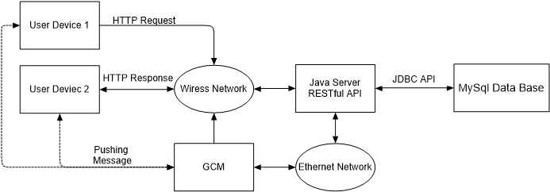

Figure. 3.1.1.1 Overall System Architecture

There are 4 main modules in the whole system: Front-end application, server, database, and GCM. The front-end application is designed for end-users, who are going to use our electronic payment service, and the front-end application is deployed in users’ end-devices, which could be portable. As for the server and database, in my demonstration, both of them are deployed in one computer, therefore the interconnection between the server and database doesn’t go through the external network, an API is needed instead. As for the GCM, it is used for pushing message to the users.

* + 1. **Front-end Application**

In this project, the front-end application is developed in Android, which is the most popular operating systems for smart phones, and Android Studio is used for development as the IDE.

Front-end application takes the responsibility of interaction with different users; therefore, principles of UI design shall be considered here like convenience, precise and be friendly to users.

* + 1. **Server Module**

In my design of this server module, a kind of special approach is considered here: RESTful API structure. REST stands for the full term of Representational State Transfer, which describes an interaction mode between client and server and RESTful API means API in REST style structure. In other words, with more generally definition, REST structure uses URL for locating resources and HTTP action for behaviors.

In fact, RESTful API is usually used in web applications because it utilizes both URL and HTTP, which are mostly used for web. However, in my mind, it could valuable implementing a RESTful API for an Android application, which means the server design is well structured and easy for modification, compared with communication by socket. For example, you may have to design your own protocol for socket communication. Moreover, with RESTful API structure, it is easy to transplant this application to a new platform of web browser.

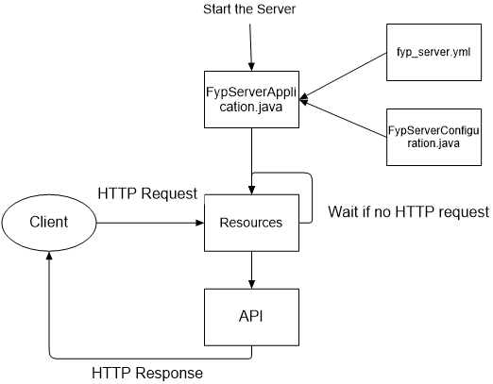

Figure. 3.1.3.1 Flow Diagram of Server

* Run file FypServerApplication.java to start the server
* File fyp_server.yml defines the port of the server
* File FYPServerConfiguration.java defines the other initial configurations
* Resource package contains all the resource files (like Login.java)
* When there is a HTTP request from the client, the server will locate the resource file according to the HTTP request with URL. If there is no request, just waiting for the activation.
* Once the resource file is located, call the API files to response. In other words, API files define the format of response
* The response is sent back to client by HTTP
  + 1. **Database Module**
       1. **Overview of Database**

MySQL is deployed here. And according to the other flow designs, 2 tables a created: table fyp_user for user information and table fyp_trans for transaction information.

* + - 1. **Table of fyp_user**

|  |  |  |
| --- | --- | --- |
| **Field/Attribute** | **Data Type** | **Description** |
| **user_id** | **int, not null** | **Primary key, auto increment** |
| **user_name** | **varchar(10), not null** | **Set to be unique** |
| **user_password** | **varchar(20), not null** |  |
| **user_emailAddr** | **varchar(20)** | **user’s email address** |
| **user_balance** | **int** | **user’s current balance** |
| **user_createTime** | **timestamp, not null** | **this account’s created time** |
| **user_lastModifiedTime** | **timestamp, not null** |  |
| **user_valid** | **char, not null** | **1 for valid, 0 for invalid** |
| **user_bankAccount** | **varchar(20)** | **user’s bank account** |
| **user_ip** | **varchar(16)** | **user’s last login IP address** |
| **user_qrValidNum** | **varchar(6)** | **6-bit random string for current QR Code generated by this user** |
| **user_qrValue** | **int** | **value information shall be contained be the current QR Code generated by this user** |

Table. 3.1.4.2 Table of fyp_user

* + - 1. **Table of fyp_trans**

|  |  |  |
| --- | --- | --- |
| **Field/Attribute** | **Data Type** | **Description** |
| **trans_id** | **int, not null** | **Primary key, auto increment** |
| **trans_fromID** | **int, not null** | **user id of payment side** |
| **trans_toID** | **int, not null** | **user id of gathering side** |
| **trans_fromName** | **varchar(10), not null** | **user name of payment side** |
| **trans_toName** | **varchar(10), not null** | **user name of gathering side** |
| **trans_fromBalance** | **int, not null** | **user’s balance of payment side** |
| **trans_toBalance** | **int, not null** | **user’s balance of gathering side** |
| **trans_value** | **int, not null** | **value of this transaction** |
| **trans_creatTime** | **timestamp, not null** |  |

Table. 3.1.4.2 Table of fyp_trans

* + - 1. **JDBC**

JDBC stands for Java DataBase Connectivity, which is a Java API used to execute SQL statement for retrieving or updating data from MySQL database.

* + 1. **GCM**

GCM stands for Google Clouding Messaging, which is used for pushing a message to the end-user device. Because the server is built in request-response mode, therefore, server cannot send a message to the user if user doesn’t give a request. GCM takes the responsibility of pushing a message to the end-user when transaction happened or finished.

* 1. **GUI Flow**

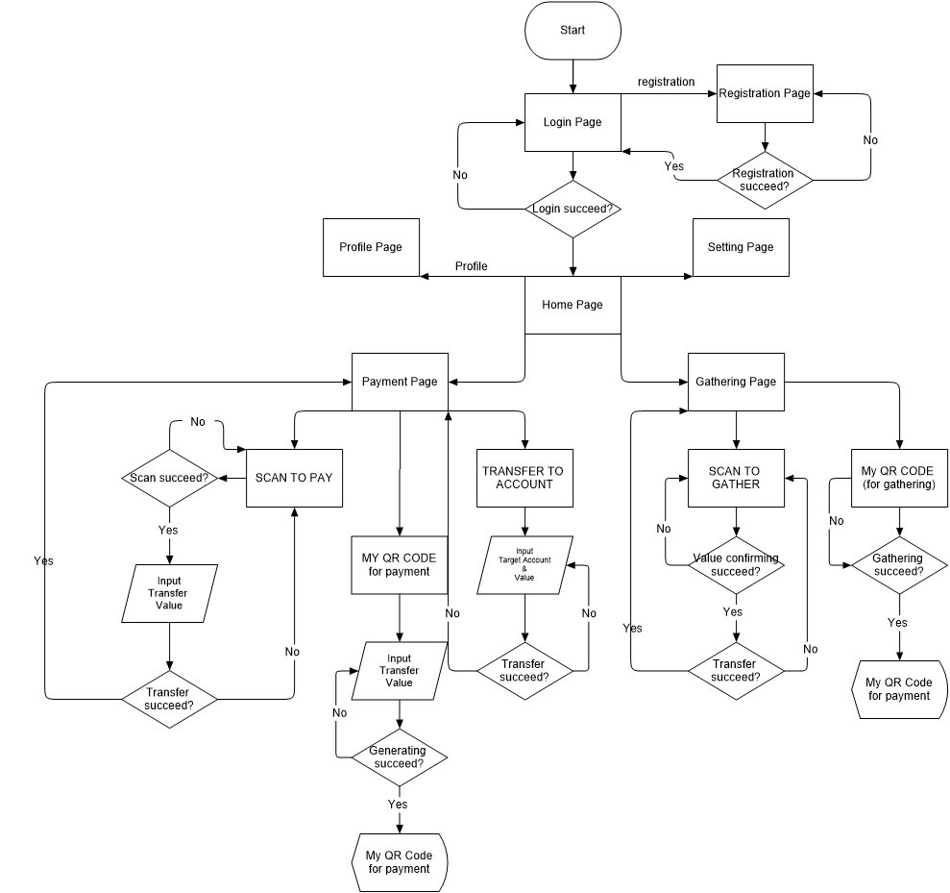

Figure. 3.2.1 GUI Flow Chart

* 1. **Data Flow**

The following data flow charts corresponds to the [Table 1.3.1 Project Scenario Definition]

* + 1. **Data flow chart of Login**

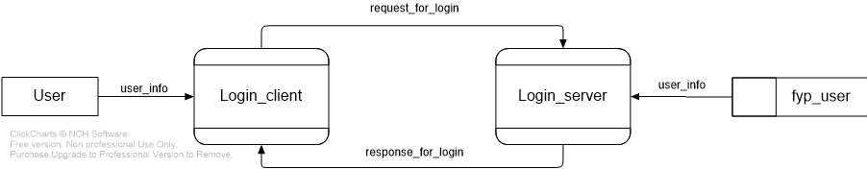

Figure. 3.3.1 DFD_Login

* + 1. **Data flow chart of Registration**

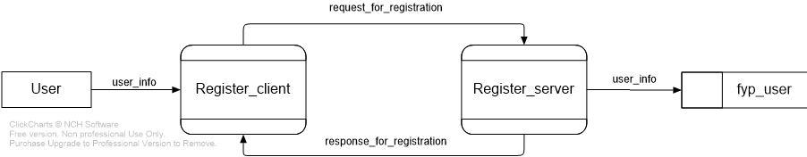

Figure. 3.3.2 DFD_Registration

* + 1. **Data flow chart of Payment_byScan**

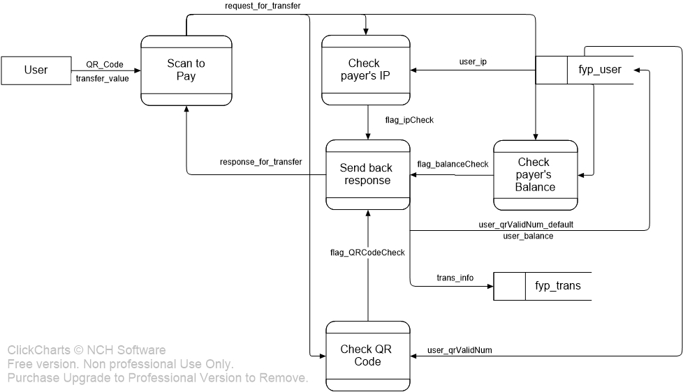

Figure. 3.3.3 DFD_Payment_byScan

* + 1. **Data flow chart of Payment_byQRCode**

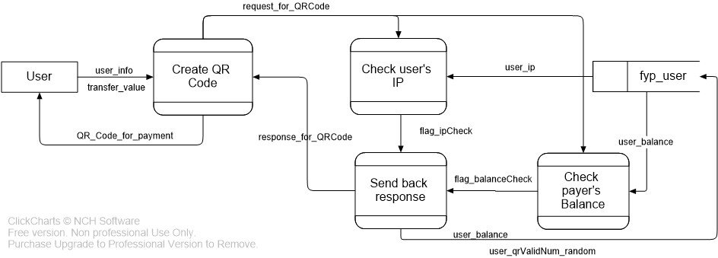

Figure. 3.3.4 DFD_Payment_byQRCode

* + 1. **Data flow chart of Payment_byTransfer**

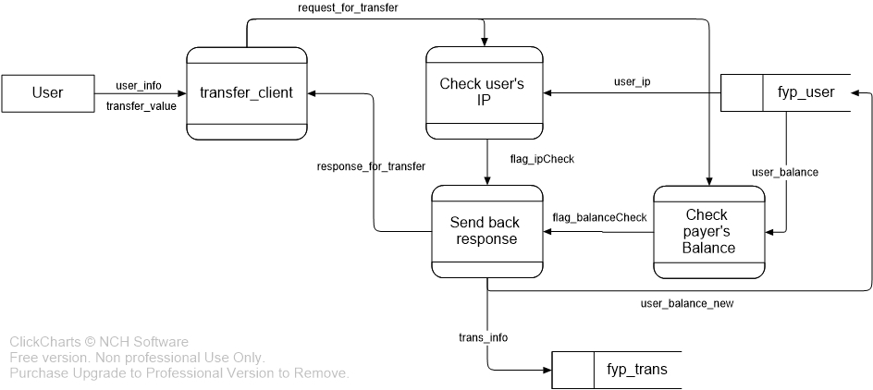

*Figure. 3.3.5 DFD_Payment_byTransfer*

* + 1. **Data flow chart of Gathering_byScan**

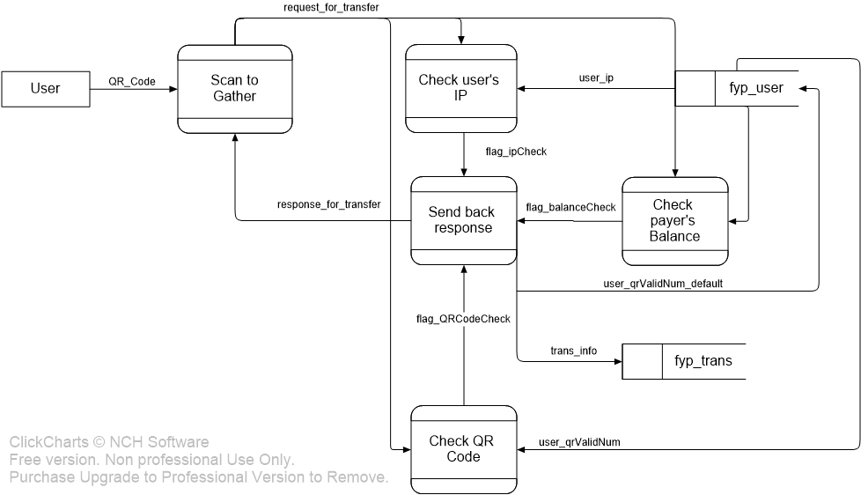

*Figure. 3.3.6 DFD_Gathering_byScan*

* + 1. **Data flow chart of Gathering_byQRCode**

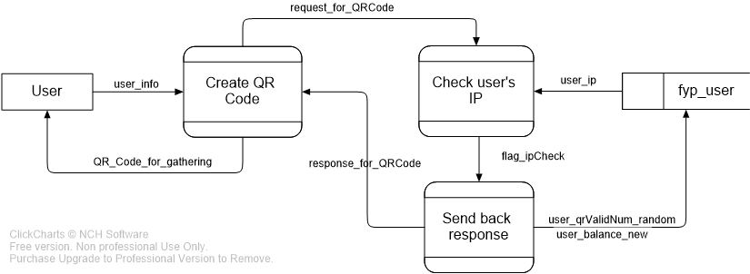

*Figure. 3.3.7 DFD_Gathering_byQRCode*

1. **Further Development**
   1. **UI design**

In this stage of project, the UI is really simple and seems to be a prototype. Therefore, one part of the further development of this application is to improve the UI design of the front-end application. The ideal UI shall be not only beautiful, which is attractive to new users, but also friendly to users.

* 1. **Implementation of Geolocation by WIFI**

Electronic payment can be considered as a method of electronic business. As far as I’m considering, this idea of geolocation by WIFI can be applied to giving the users some shop recommendations while they are nearby. The specific location of the user is calculated by WIFI signals around the user. Compared to geolocation by GPS, geolocation by WIFI has some advantages like no need to change the current WIFI networks. As time goes by, there’re more and more access points built around, which helps geolocation by WIFI method becoming more fast and accurate.

* 1. **Implementation of GCM**

GCM, the Google Clouding Messaging is a service implemented for sending a message to user even though there is no request from the user device. This is useful because our server is designed in mode of request-response. Sometimes we need unidirectionally send message to the user, therefore the GCM is need. However, the technical details of GCM will be considered later.

1. **Conclusions**

This project called “Mobile Web Application - Electronic Payment System”, which is focusing on the system architecture design and practical implementation. The final goal is to design and develop a full functional electronic payment system with capabilities of convenience, safety and user friendly. Multiple technical tools and methods are involved in this project like Android programming, RESTful API developing for a Java server, database technology, cloud message pushing system and so on. Furthermore, in the later stage of this project, it’s necessary to improve for a better UI, a better security method and the implementation of geolocation by WIFI.